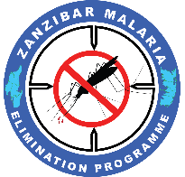

SUMMARY REPORT FOR MASS REPLACEMENT CAMPAIGN IN
53 SHEHIA OF ZANZIBAR

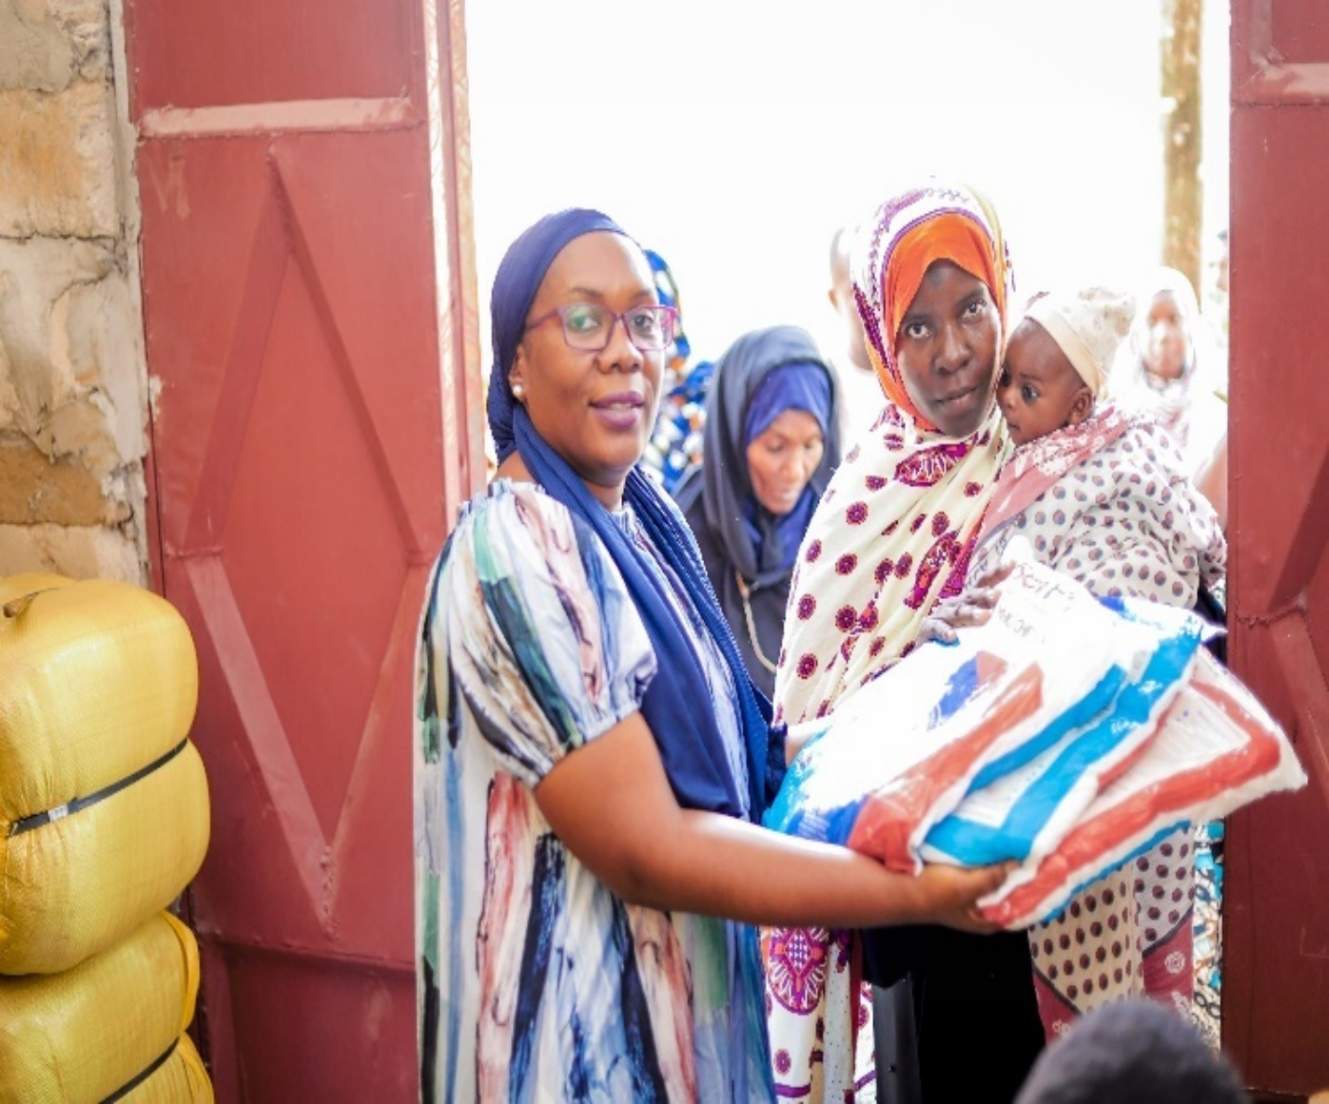
TaskforceTaskforceLets change the picture and insert the minister-MoH when he was launching the campaign

Prepared by ZAMEP
21st August 2023

Table of contents
1. Introduction 3
2. Objective of the campaign 3
3. Formulation of MRC Taskforce 3
4. Households’ registration 3
5. Pretest of the electronic registration system 4
6. Launching of the campaign 4
7. Community sensitization 5

Introduction
Zanzibar has completed the Mass Replacement Campaign (MRC) in fifty-three (53) Shehia from West ‘A’, West ‘B’ and Urban districts. This was typical replacement of Long Lasting Insecticide Treated Nets (LLINs) that was issued in 2020 for the purpose of preventing people from getting malaria infection. The 2020 MRC implementation was deployed due to the observed and reported abnormal number of malaria cases for a duration of three months with a cutoff point of at-least five cases a month. However, the difference of the 2023 MRC from the 2020 distribution was replacing the old with new LLINs considering the life of LLINs of two years and a half to three yrs.

The 2023 MRC has been implemented very successfully by ZAMEP in collaboration with different stalk holders such as US Presidents Malaria Initiative, USAID Tanzania Vector Control Activity, Breakthrough ACTION, Digital Square, Simba Logistics, district authorities and the community members who were the main beneficiaries from the covered Shehia.

Objective of the campaign
The objective of the campaign was to replace new LLINs from the old LLINs that were issued in 2020. A total of 205,000 PBO LLINs were issued by then on the same 53 shehias and districts. Post the 2020 campaign, the outcome was a reduction of malaria cases documented within a week.

Planning, coordination, and management of the campaign

3:1. Formulation of MRC Taskforce
During the initial phases of the preparation for MRC, a taskforce was formulated to coordinate planning and eventually implementation of all activities. . The major roles of MRC taskforce were to provide technical support, recommend to ZAMEP technically on the best way of the distribution modality starting from receiving LLINs, clearance, storage, registration approach and final distribution modality. Furthermore, the taskforce provided guidance on community mobilization through social behavior change to ensure beneficiaries are reached with appropriate information regarding the LLINs distribution campaign.The taskforce comprised members US Presidents Malaria Initiative, USAID Tanzania Vector Control Activity, Breakthrough ACTION, Digital Square, Simba Logistics

3:2. Households registration
This was conducted by trained community volunteers from individual Shehia that were targeted. At-least six community volunteers were trained in each Shehia for three days to complete the training contents in order to be competent enough to deliver services of household registration and final net issuing to selected distribution posts at the Shehia level.

The household registration was conducted by using electronic system to obtain accurate collected information that simplify LLINs quantification and score actual number of LLINs that need to be given by individuals. This was the first time for Zanzibar to use the electronic registration system that so far has shown good outcomes, although there are some technical aspects that need to be fixed for the system to function at an optimal level. The registration process mainly collected most important personal particulars information such as three names of the head of household, living address, phone number, and number of people in individual household. That information was also recorded in the physical coupon that was issued to individual households.

3:3. Pretest of the electronic registration system
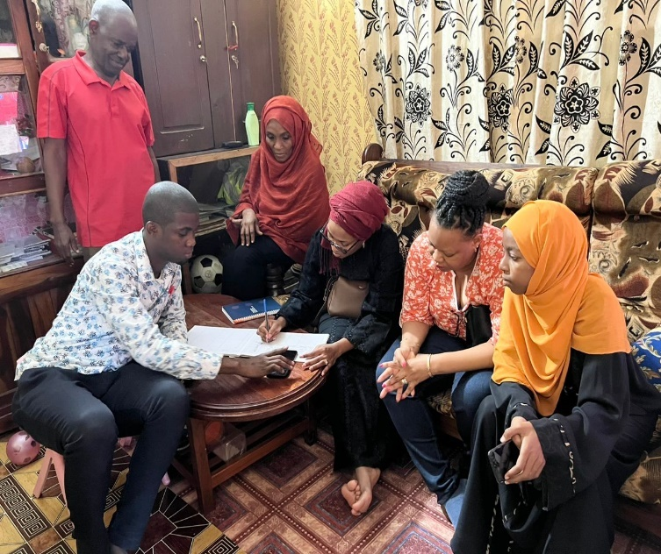
As a procedure to obtain quality works, this was conducted in three selected Shehia that were not included in the MRC.
Four days were used to complete the entire pretest exercise, resulting in very good performance. However, there were some minor technical challenges that were identified in the system. Recording of alphabet and numerals, wrong counting for the number of nets versus number of household members registered were among the documented challenges for the electronic system.

Training of registration assistants for MRC 2023

3:4. Launching of the campaign
The launching event of the MRC 2023 was conducted on 25th July one day before the actual LLINs issuing started. The event was attended by different high-level peoples headed by Guest of honor Minister for Health Zanzibar Hon. Nassor Ahmed Mazrui who provided very educative speech on the importance of timely collection of LLINs at issuing posts and community LLINs utilization once person received LLINs. During his speech he provided vote of than to USAID and Global Funds for intensive support to eliminate malaria Zanzibar.

Among others in attendence was the Deputy Director for Health from USAID Tanzania, directors from the Ministry of Health Zanzibar, District Commissioner from Urban, district Administrators from Urban, West ‘A’, and West ‘B’ districts, Program Officers from the Ministry of health and district authorities including Sheha and assistant Sheha from 53 Shehia that have been involved in the MRC. The deputy director for Health from USAID on behalf of Presidential Malaria Initiative, pledged to continue to provide support to improve community health to Tanzanian including malaria elimination support in Zanzibar. She prouded good collaboration between Tanzania and USA in terms of the development aspect in each country.

3:5. Community sensitization
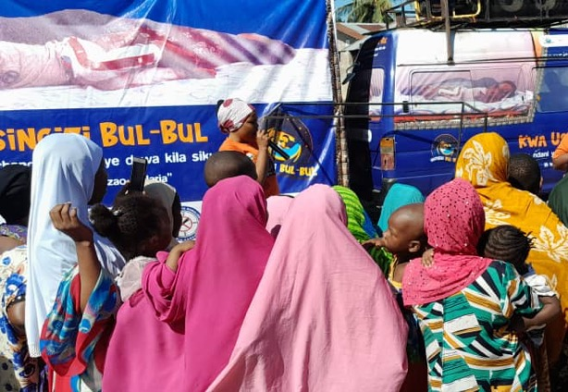
This is very important pillar to support any public health intervention including malaria elimination movement. The Social Behavior Change (SBC) activities aimed to inform targeted community members on the entire process of MRC.

This have been done intensively to all 53 shehia that were involved in the MRC.

To support MRC, the SBC activities were implemented in three phases to ensure that targeted community members are aware of entire MRC with the three key major sensitization messages
Community sensitization entitled usingizi bul bul campaign, name location and the credit the photographer

- The first message during the first phase was to inform community members of the importance of participating during the registration as a main condition for eligibility to be issued with an LLINs.
- The second phase was to inform community members on the importance of collecting LLINs during the LLINs issuing dates to all selected issuing posts at the Shehia level
- The third phase informed the community on the importance of using/sleeping under LLINs continuously for malaria prevention
- The fourth phase will be conducted by using different community channels with a sustainability approach that will involve different stakeholders, particularly from district health management teams, key community influential people, Community Health Workers and others. To make successful the community awareness the ZAMEP also will work closely with Health Education Program of the Ministry of Health Zanzibar

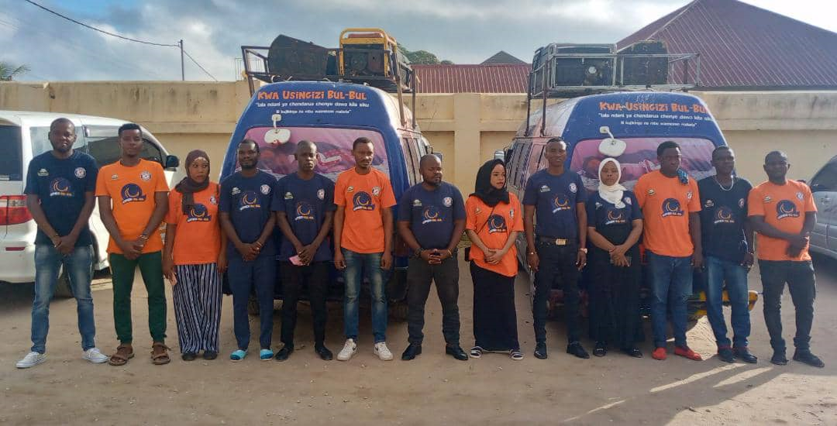
In the implementation of SBC activities different channels of communication were used to ensure that appropriate information regarding MCR was delivered to targeted people. Among the channels used included mass media through live radio and television programs, media interviews, Public Services Announcement, and print as well as distribution of IEC materials such as posters, leaflets, and T-shirts.
Most of implemented SBC activities were supported technically and financially by USAID through BreakThrough ACTION project Tanzania. The SBC activities were implemented intensively all over the distribution areas (53 Shehia) that have been involved in the campaign.
Amplify performed very important task of comm sensitization through community wider events (PSAs)

3:6. LLINs Issuing to household members
The table below indicates number of LLINs issued during the MRC 2023 per district
SN | Districts | Baseline HH | Registered HH | Baseline population | Registered population | Estimated no of LLINs | LLINs issued | % of LLINs issued
1 | Mjini | 27,745 | 27,876 | 131,095 | 137,671 | 76,286 | 65,662 | 86%
2 | Magharibi ‘A’ | 24,564 | 25,260 | 124,633 | 143,196 | 77,673 | 69,070 | 89%
3 | Magharibi ‘B’ | 30,671 | 29,063 | 150,191 | 170,759 | 92,523 | 78,832 | 85%
 | TOTAL | 82,980 | 82,199 | 405,919 | 451,626 | 246,482 | 213,564 | 87%

Based on the above table, 87% coverage of household LLINs issued to beneficiaries was attained within ten days window of issuing the nets. This achievement this achievement is attributed to the commitment from community net distributors, intensive monitoring and supervision that has been conducted jointly between ZAMEP, TVCA and BA teams in collaboration with district authorities from three districts that have been involved in the MRC 2023. A 100% record was not attained due to various operational challenges, including but not limited to some members refusal to collect their nets even if they had registered an aspect that needs to be looked at and uncover the reasons behind this anomaly.

ZAMEP received a total of 247,660 LLINs for MRC 2023 from PMI and Global Fund aiming to cover a total of 53 Shehia from Urban, West ‘A’ and West ‘B’ districts. According to the household registration, 246,482 LLINs micro-quantified to be issued to registered people from 170,759 households.
Out of 247,660 LLINs received, a total 221,683 LLINs have been issued during the campaign meanwhile a total of 25,977 LLINs remain in the Mombasa warehouse. However, ZAMEP also having a total of 4,023 LLINs that were reserved for response activities in hotspot and active foci areas. With the consideration of life span of LLINs (2.5yrs) the remaining portion of LLINs should no longer kept in the warehouse in order to have effective insecticides that can kill or repeal malaria mosquitoes.

3:7. Operational challenges
There were no major operational challenges that could negatively impact the smooth implementation of LLINs distribution campaign to all 53 Shehia. However, the following challenges were identified during the phases of the household registration and LLINs issuing
- Thirteen percent of registered community members did not appear to collect their nets despite extended collection from five to ten days of issuing.
- Few community members refused to be registered during the time of household registration.
- Some Shehia registered many people while others registered less compared with 2022 population and housing census. Stone town Shehia in Urban district registered less people while some Shehia from West ‘A’ and ‘B’ registered much more than expected.
- The electronic issuing system did not operate very well during the first two days of registration which might have pushed some people away due to malfunctions.
- The The electronic issuing system could not recognize some coupons identities, this created some disturbances especially during the first two days of issuing

4:0. Way forward
ZAMEP in collaboration with its implementing partners is still developing a full MRC implementation report that will document in more details all the processes that have been narrowly discussed here. Once the full report is completed, it will be shared widely with all partners and government officials.

5:0. Recommendations
The following are ZAMEP's recommendations for the remaining balance of LLINs:
- All remaining LLINs (30,000pcs) should be distributed to Shehia that are still reporting an abnormal number of malaria-positive cases. Based on current ZAMEP SME data, most of Shehia from South district of Unguja are more infected compare with others. In that sense, priority for the distribution should be given to South district to minimize transmission.
- ZAMEP recommends and is requesting PMI to provide financial support through TVCA to facilitate the distribution as soon as possible since the sporadic transmission is on going in South parts of the Island
- Due to current documented technical glitches facing the electronic registration system, ZAMEP recommends exploring the traditional method of household registration as the new system goes through improvements and be ready for the next big scope MRC in 2024.

